Muhammad Zain Ali
22i-0562
PF-LAB13
AI-D

#include <iostream>
using namespace std;

void Task2();
void Task3();
void Task4();
void Task5();
void Task6();
void Task7();
void insertinto(int matrix1[5][5]);
void thirdfunc(int matrix2[5][5] ,int matrix1[5][5]);
void square(int&, int&);

int main()
{

int task = 0;
cout <<"Select Task to be executed BETWEEN 2 - 7:\n";
cin >> task;

if (task >= 2 && task <= 7)
{
if (task == 2)
{
Task2();
}
else if (task == 3)
{
Task3();
}
else if (task == 4)
{
Task4();
}
else if (task == 5)
{
Task5();
}
else if (task == 6)
{
Task6();
}
else if (task == 7)
{
Task7();
}

}
else
cout <<"Enter a valid Task number!!!\n";

return 0;
}
//Task 2 below

void Task2()
{
// Sum of 2 MAtrices
int matrix1[5][5] ;

cout <<"Enter the rows of a 5x5 Matrix:\n";
cout <<"I will add 2 in all entries.\n";
for (int i = 0; i < 5; i++)
{
for (int j = 0; j < 5; j++)
{
cin >> matrix1[i][j];
}
}

cout <<"Your Original Matrix is \n";
for (int i = 0; i < 5; i++)
{
for (int j = 0; j < 5; j++)
{
cout <<matrix1[i][j]<<" ";
}
cout << endl;
}

insertinto(matrix1);

}

//INSERTINTO function of TASK 2

void insertinto(int matrix1[5][5])
{
int matrix2[5][5];

for (int i = 0; i < 5; i++)
{
for (int j = 0; j < 5; j++)
{
matrix2[i][j] = 2 + matrix1[i][j];
}
}

cout <<"After addition of 2 in original matrix:\n";

for (int i = 0; i < 5; i++)
{
for (int j = 0; j < 5; j++)
{
cout <<matrix2[i][j] <<" ";
}
cout << endl;
}

thirdfunc(matrix2, matrix1);

}

//THIRDFUNC function of INSERTINTO function of TASK 2

void thirdfunc(int matrix2[5][5], int matrix1[5][5])
{
int matrix3[5][5];

for (int i = 0; i < 5; i++)
{
for (int j = 0; j < 5; j++)
{
matrix3[i][j] = matrix1[i][j] + matrix2[i][j];
}
}

cout <<"After addition of Matrix 2 with original matrix:\n";

for (int i = 0; i < 5; i++)
{
for (int j = 0; j < 5; j++)
{
cout <<matrix3[i][j] <<" ";
}
cout << endl;
}
}

//Task 3 below

void Task3()
{
//This program is for the multiplication of two 4 cross 4 matrices

int matrix1[4][4];
int matrix2[4][4];
int matrix3[4][4];
int sum = 0;
cout <<"Enter the entries of 1st matrix of order 4x4:\n";

for (int i = 0; i < 4; i++)
{
for (int j = 0; j < 4; j++)
{
cin >> matrix1[i][j];
}
}

cout <<"Enter the entries of 2nd matrix of order 4x4:\n";

for (int i = 0; i < 4; i++)
{
for (int j = 0; j < 4; j++)
{
cin >> matrix2[i][j];
}
}

//Showing both matrices

cout <<"Your 1st matrix of order 4x4 is:\n";

for (int i = 0; i < 4; i++)
{
for (int j = 0; j < 4; j++)
{
cout << matrix1[i][j] << " ";
}
cout <<endl;
}

cout <<"Your 2nd matrix of order 4x4 is:\n";

for (int i = 0; i < 4; i++)
{
for (int j = 0; j < 4; j++)
{
cout << matrix2[i][j] << " ";
}
cout <<endl;
}

for (int i = 0; i < 4; i++)
{
for (int j = 0; j < 4; j++)
{
for (int k = 0; k < 4; k++)
{
sum = sum + matrix1[i][k]*matrix2[k][j];
}
matrix3[i][j] = sum;
sum = 0;
}
}

cout <<"Your 3rd matrix of order 4x4 is:\n";

for (int i = 0; i < 4; i++)
{
for (int j = 0; j < 4; j++)
{
cout << matrix3[i][j] << " ";
}
cout <<endl;
}

}

//Task 4 below

void Task4()
{

//This program has a function which calculate the square of both the values entered by user. (Using call be reference)

int num1 = 0;
int num2 = 0;

cout <<"Enter 2 values in integer to get square of them.\n";
cout <<"Enter 1st number: \n";
cin >> num1;
cout <<"Enter 2nd number: \n";
cin >> num2;

square(num1 , num2);

cout << "Square of 1st number is " <<num1<<endl;
cout << "Square of 2nd number is " <<num2<<endl;
}

//SQUARE function of TASK 4
void square(int &x , int &y)
{
x = x*x;
y = y*y;
}

//Task 5 below

void Task5()
{
/*Consider an integer 2D-array of size 6x6. This program find those pair of elements that has the maximum and minimum difference among all element pairs.*/

int matrix[6][6];

cout <<"Enter a 6x6 Matrix Below!\nEnter Row wise numbers in 6 rows:\n";
for (int i = 0; i < 6; i++)
{
for (int j = 0; j < 6; j++)
{
cin >> matrix[i][j];
}
}

cout <<"Your Entered matrix is:\n";
for (int i = 0; i < 6; i++)
{
for (int j = 0; j < 6; j++)
{
cout << matrix[i][j]<<" ";
}
cout << endl;
}

for (int i = 0; i < 6; i++)
{
for (int j = 0; j < 6; j++)
{
matrix[i][j]
}
}

}
//Task 6 below

void Task6()
{
//This Program finds te sum of diagonal elements of a 2d matrix

int n= 0;
cout <<"Enter the value of n:\n";
cin >> n;
cout <<"Enter the elements of a n cross n matrix:\n";
int Matrix[n][n];
for (int i = 0; i < n; i++)
{
for (int j = 0; j < n; j++)
{
cin >> Matrix[i][j];
}
}

int sum = 0;

for (int i = 0; i < n; i++)
{
for (int j = 0; j < n; j++)
{

if (i == j)
{
sum = sum + Matrix[i][j];
}
}
}
cout <<"The sum of diagonal entries is: "<<sum<<endl;
}

//Task 7 below

void Task7()
{
//This program check if elements of columns of array are same as of elements of rows array.

bool con = false;
int n = 0;
cout << "Enter a matrix to check it is symmetric or not!\nEnter order of Matrix:\n";
cin >> n;
int matrix[n][n];
cout << "Enter entries:\n";

for (int i = 0; i < n; i++)
{
for (int j = 0; j < n; j++)
{
cin >> matrix[i][j];
}
}
cout <<"Your entered matrix is: \n";

for (int i = 0; i < n; i++)
{
for (int j = 0; j < n; j++)
{
cout << matrix[i][j] << " ";
}
cout << endl;
}

for (int i = 0; i < n; i++)
{
for (int j = 0; j < n; j++)
{
if(matrix[i][j] == matrix[j][i])
{
con = true;
}
}
}

if (con == true)
{
cout <<"It is a symmetric matrix.\n";
}
else
cout <<"It is not a symmetric matrix.\n";
}
Task 2

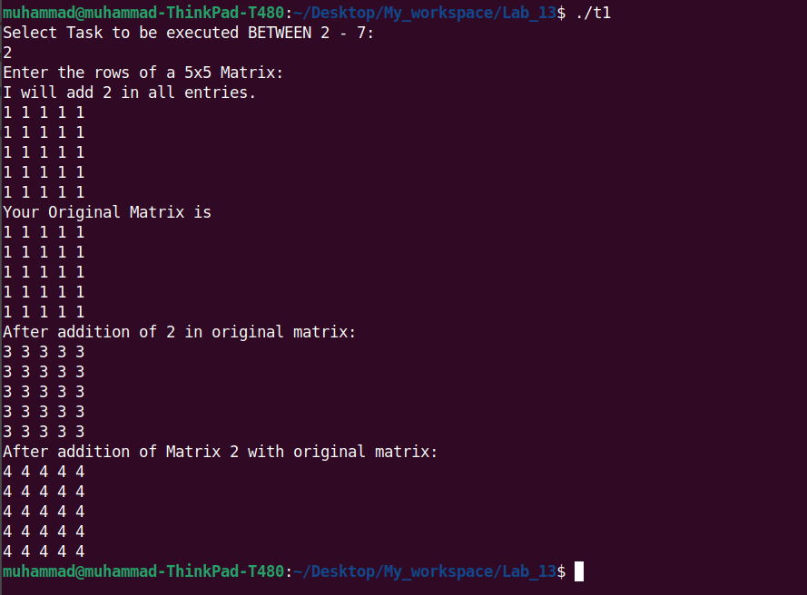

Task 3

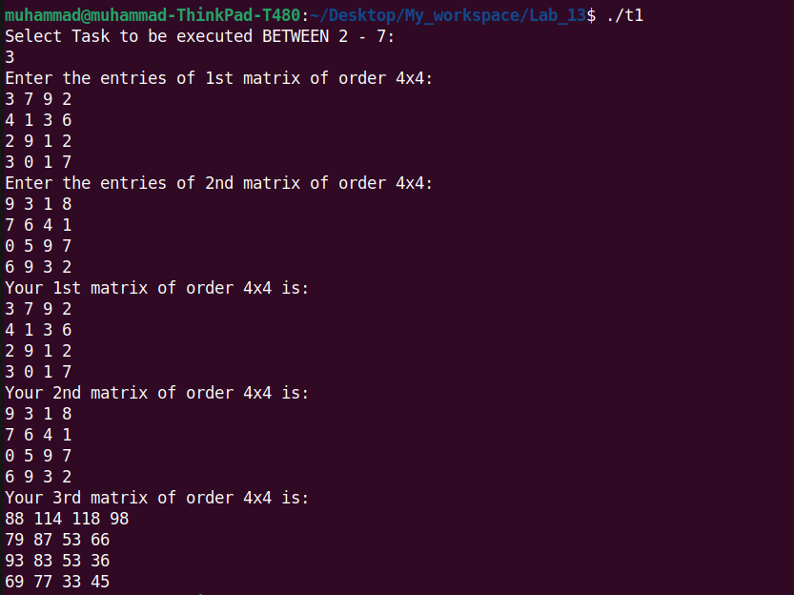

Task 4

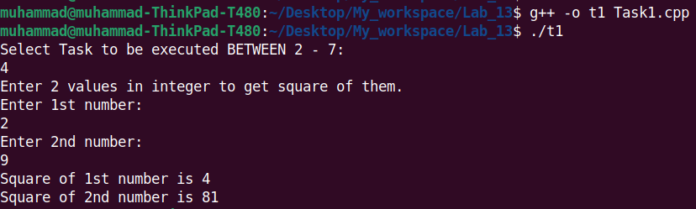

Task 6

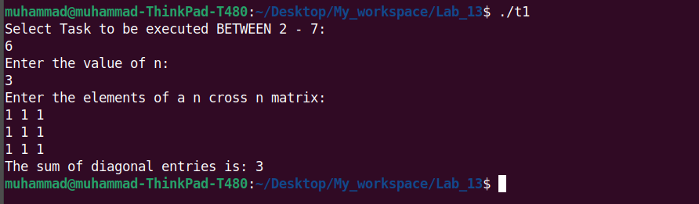

Task 7

